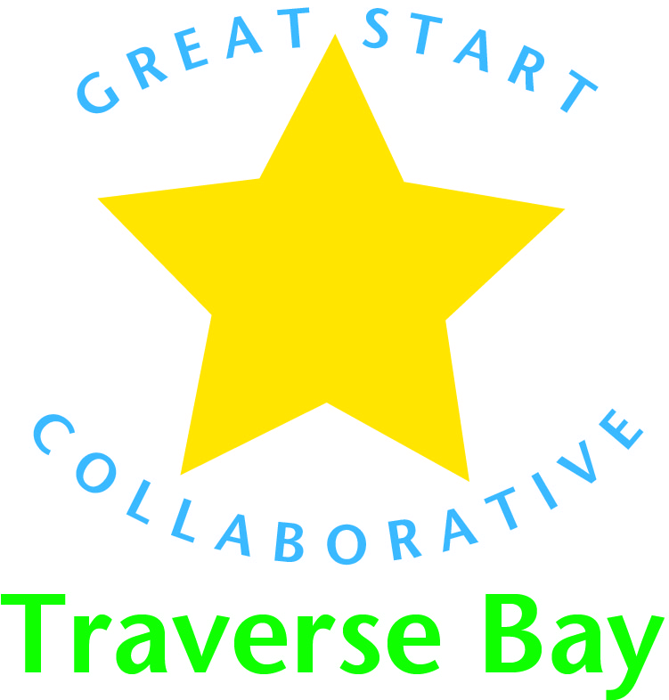

MEDIA RELEASE August 20, 2015

TRAVERSE CITY – The Association of Chamber of Commerce Executives (ACCE) honored the Great Start Collaborative Traverse Bay with its Regional Innovation Award presented at its annual convention last week in Montreal, Canada. The award recognizes organizations that build stronger communities through groundbreaking program development and collaboration among partners, and was presented to Great Start Coordinator Mary Manner.
“To be nominated as a finalist for the ACCE Regional Innovation award from among 21 candidates was an honor. For the Great Start Collaborative to win the award representing our Chamber and Venture North, the Traverse Bay Area Intermediate School District and all our Great Start partners is extraordinary,” Manner said. “It was a proud moment for me to accept the award on behalf of all our early childhood partners, and to know that our work in promoting investment in child development is being recognized by our peers in the business community.”
The Great Start Collaborative Traverse Bay is a partnership between Venture North Funding and Development and the Traverse Bay Area Intermediate School District. It focuses on early childhood development as a driver of regional economic development. It brings together community leaders, families and caregivers to create advanced early childhood systems through the area that support family health, early literacy and expanded child care options.
Doug Luciani, CEO of TraverseCONNECT and co-chair of the Children’s Leadership Council of Michigan, praised the work and accomplishments of the Great Start team. Luciani spearheaded the effort to bring the area Great Start Collaborative under the Traverse City Area Chamber of Commerce several years ago in partnership with the TBAISD. Great Start now operates under Venture North, the economic development arm of TraverseCONNECT and a sister organization of the Chamber.
“The Chamber made early childhood development a priority more than a decade ago. Through the tireless work of dozens of volunteers and world-class staff, the state’s finest Intermediate School District, and major financial commitments from such companies as Consumers Energy and DTE, our five-county region’s Great Start Collaborative has distinguished itself as a national leader,” Luciani said. “This recognition by our peers at the ACCE confirms and reinforces that our efforts are indeed best of class. It is also a great ‘boots on the ground’ complement to the Chamber’s advocacy efforts for increased resources for early childhood programs.”
The Traverse Bay Great Start Collaborative was among four finalists among the 20-plus nominees considered for the Regional Innovation Award. Other finalists included a program to expand the skilled workforce for aviation and advanced manufacturing companies around Greensboro, N.C., a business corridor project in Fort Collins, Colo., and a summer teen employment program in Flint.
“To be recognized by the Association of Chamber of Commerce Executives is a tribute to the dedicated and passionate advocates of early childhood education throughout our five counties,” said Michael Hill, Superintendent of the TBAISD. “Hundreds of providers, practitioners, parents and community members have joined together to support an early childhood system aimed at preparing all students for success in school. This is a prestigious award we are honored to receive.”
Learn more about Great Start Collaborative Traverse City by visiting its website at http://greatstartkids.com/

